Strategic Planning & Assessment Council Goals for AY 2019 – 2020 (and beyond)

Sustainable Development as a Framework for Planning
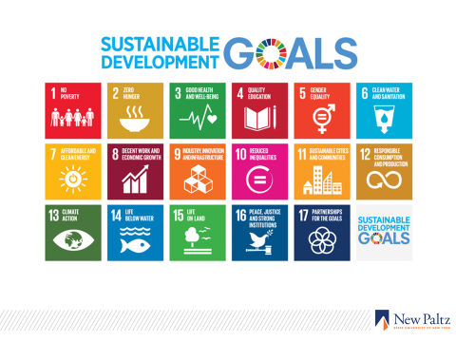
Around the United Nations Sustainability Development (UN SDG) Goal 4, all other goals can work together to create a meaningful framework into which fits almost all aspects of our work across the institution. In accord, use the UN SDGs as a framework to:
- Articulate campus-wide planning framework
- Create planning checklist that connects unit planning to campus mission and Strategic Plan goals
- Develop a shared vocabulary
- Support the campus’s development of a common understanding of the connections between the SDGs and Strategic Plan Essential Initiatives and related institutional goals and priorities
- Align and articulate targets
- Encourage process/skill development
- Draw upon the following themes outlined in the SUNY Chancellor’s State of SUNY address in fore- fronting sustainability
- Individualized education
- Innovation and entrepreneurship, including scholarship and research
- Sustainability
- And all underpinned by partnerships
- Integrate sustainable development into our Middle States Self-Study (see #2 below)

Institutional Priorities to be Addressed in the Middle States Self-Study

New Paltz will pursue the following institutional priorities for this self-study:

- Nurture a learning environment founded on critical thinking, creativity, and the growth and sharing of knowledge
- Cultivate sustainability in all its forms, including institutional, social, economic, and environmental sustainability
- Forge community and enhance our commitment to diversity, equity, and inclusion
- Increase accessibility of undergraduate and graduate education in the region

- Begin thinking about developing a new strategic plan based on planning framework and Global Goals.

Connect planning goals to targets/metrics/assessments
- Help academic and academic support units to connect their planning goals to broader campus goals and institutional targets/metrics/assessments (e.g., connecting institutional, general education (GE), and program goals to assessments)

Middle States
- Support the Standard 1 Working Group to fulfill its charge. The Council has representation from a wide range of schools and departments and a clear perspective of how the criteria in Standard 1 have been addressed in the Strategic Plan. A member of the Self-Study Steering Committee chairs each Working Group, thereby increasing coordination and efficiency between Working Groups.
- Work with the Middle States Steering Committee and chairs to collect and interpret data for the self-study, paying close attention to how the criteria in Standard 1 have been addressed in the Strategic Plan

Excellence in Academic Advising – Support the Excellence in Academic Advising (EAA process) (e.g., provide feedback on oral and written reports to the Council from Dante Cantu and others)

